William Mackay
MTH 337, Professor Adam Cunningham

Weekly Report 09
Introduction
The Global Positioning System (GPS), since its implementation in the late 1970s, has become an important part of both military operations and civilian life. Many people use this system on a daily basis to navigate while traveling. The GPS is composed of a large constellation of satellites that constantly transmit their position and the time according to their internal clocks. As long as at least four satellites are visible, it is possible to calculate one's position on the planet. Because the satellites' positions are always known and the distance between the user and each satellite is known, it is possible to find the position of the user. This can be visualized by imagining four spheres whose centers are the positions of each satellite and whose radii are the distances between the satellites and the user. The intersection of all four spheres is the position of the user. In order to better understand this system, a simplified, 2-D version of the GPS was implemented in Python. This simplified system was then used to find the exact position of a tape marker on the floor of the classroom based on data from four “satellites” (other tape markers on the floor of the classroom).
Approach
In the simplified version of the GPS, four circles were used instead of spheres. These circles, like the spheres, had centers located at the position of each “satellite” and had radii equal to the distance from the center to the marker. The “satellites” were actually other tape markers whose positions in the classroom and distance from the first marker were known. The data for the four “satellites” are shown in Table I.
Table I
Satellite Name | x Position (m) | y Position (m) | Distance from Marker (m)
Recalculate | 5.53 | 2.23 | 2.72
Westboro Baptist Church | 4.44 | 8.45 | 3.63
Pyrite | 0.045 | 0.381 | 6.75
Alexander Hamilton | 6.67 | 5.62 | 1.77
In order to find the intersection of the four circles, the function for GPS error was minimized using a stumbledown algorithm. This GPS function took a two element array as an input which represented a pair of coordinates on the x-y plane. The function then calculated the sum of the squares of the differences of the distance from the input to each satellite and the distance from each satellite to the marker. This can be expressed using the equation, where x_{i}, y_{i}, and d_{i} are the x position, y position, and distance to the marker, respectively, for each satellite (1 through 4). The stumbledown algorithm, implemented as the function stumbledown in Python, took as inputs the initial position p, the function to be minimized, the initial step size, and, optionally, the maximum number of iterations (which defaulted to 1000). Each iteration, this algorithm used Python's rand function to create a new point q which was within a square whose side length was twice the step size and which was centered at p. p and q were then plugged into the function to be minimized, in this case GPS. If f(q) was smaller than f(p), p was replaced by q and a blue line with dot markers was plotted between the original p and the new point. If this was not the case, then p remained the same and a red line was plotted between the failed point and p. For each failure, the variable nfails increased by 1. If nfails reached 10, the step size of the function was halved. Once the step size had reached 10⁻⁹, the loop was broken and the final position and number of iterations was returned. If the step size never reached the minimum, the position and number of iterations after 1000 iterations was returned.
Results
Figure 1 shows each satellite and its surrounding circle. Figure 2 shows a zoomed in view of the intersection of the satellite circles. Figure 3 shows the results of the stumbledown algorithm. The final position of the marker, according to the stumbledown algorithm, was (5.060647404760037, 4.891993900587098)
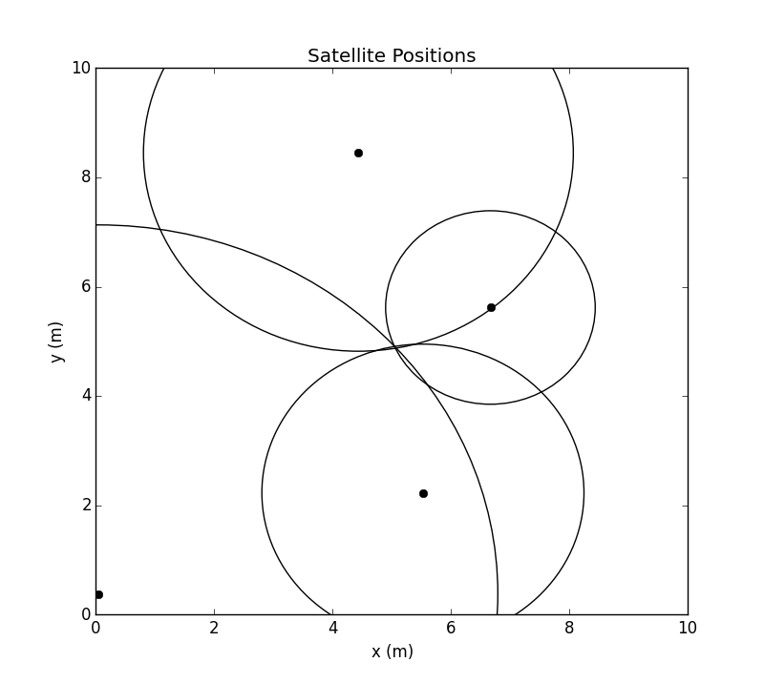Figure 1

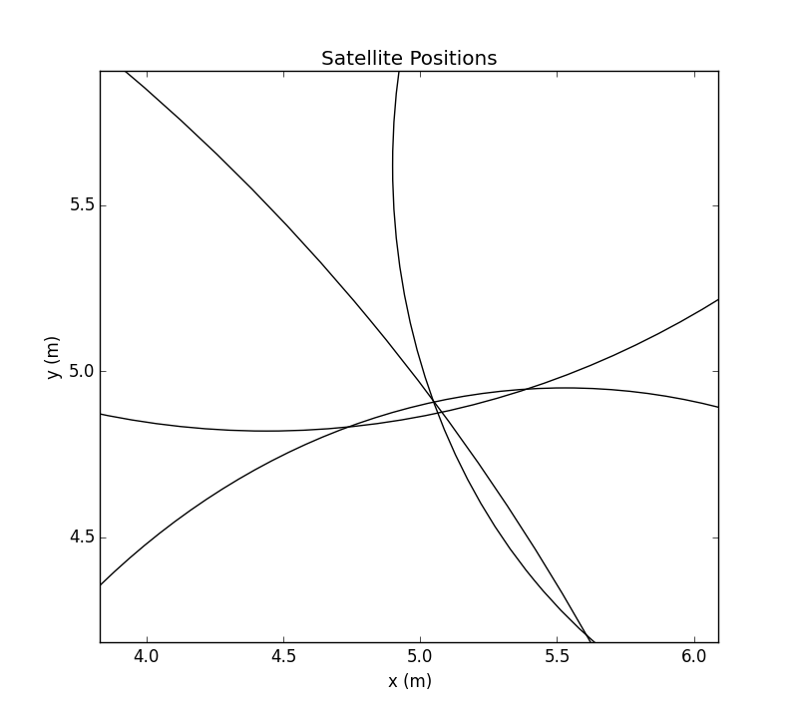Figure 2

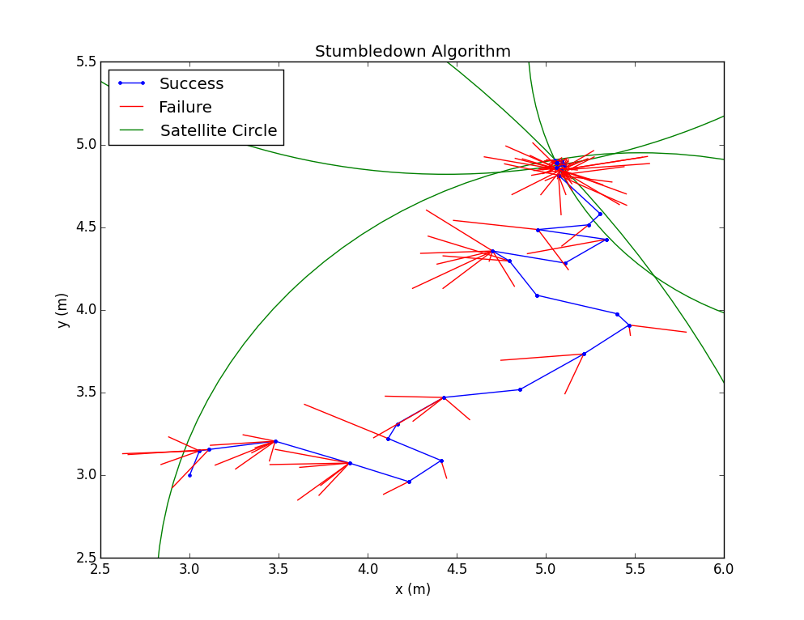Figure 3
Conclusion
From the figures in the results section, it appears that the stumbledown algorithm was successful. The final position, (5.060647404760037, 4.891993900587098), was almost exactly at the location of the intersection of the four circles. This final position did not vary by more than 10⁻⁸ on successive runs. Though this position is very precise, the accuracy is heavily dependent on measurements that were taken in class. These measurements were taken relatively quickly and were only accurate to, at most, 0.05cm. The implications of the inaccuracy of the measurements can be seen in Figure 2, which shows that the four circles do not exactly intersect at 1 point. This means that the position that was given by the stumbledown algorithm may not be the exact position of the marker. Given more accurate “satellite” positions, the accuracy of the algorithm would improve.
Python Code
#Assignment 9- GPS System Simulation
#William Mackay
#MTH 337, Professor Adam Cunningham

from pylab import *

#"Satellite" Data in Meters
xi=array([5.53,4.44,0.045,6.67])
yi=array([2.23,8.45,.381,5.62])
d=array([2.72,3.63,6.75,1.77])

def stumbledown(f,p,stepsize,n=1000):
nfails=0
for i in xrange(n):
q=[2*stepsize*rand()-stepsize+p[0],stepsize*rand()-(stepsize/2)+p[1]]
if f(q)<f(p):
plot([p[0],q[0]],[p[1],q[1]],'b.-')
p=q
nfails=0
else:
plot([p[0],q[0]],[p[1],q[1]],'r-')
nfails+=1
if nfails>10:
nfails=0
stepsize=stepsize/2
if stepsize<(10**-9):
break
return p,i

def GPS(X):
xi=array([5.53,4.44,0.045,6.67])
yi=array([2.23,8.45,.381,5.62])
d=array([2.72,3.63,6.75,1.77])
return sum((sqrt((X[0]-xi)**2+(X[1]-yi)**2)-d)**2)

figure(1)
axis([0,10,0,10])
for i in xrange(4):
circle1=Circle((xi[i],yi[i]),d[i],color='k',fill=False)
ax = gca()
gca().add_artist(circle1)
plot(xi[i],yi[i],'ko')
xlabel('x (m)')
ylabel('y (m)')
title('Satellite Positions')

p=[3,3]
stepsize=.5

figure(2)
position,iterations=stumbledown(GPS,p,stepsize,n=2000)
for i in xrange(4):
circle1=Circle((xi[i],yi[i]),d[i],color='g',fill=False)
ax = gca()
gca().add_artist(circle1)
xlabel('x (m)')
ylabel('y (m)')
title('Stumbledown Algorithm')

blue_line = Line2D([], [], color='blue', marker='.', label='Success')
red_line = Line2D([], [], color='red', label='Failure')
green_line = Line2D([], [], color='green', label='Satellite Circle')
legend(handles=[blue_line,red_line,green_line],loc='upper left')

print 'The position of the marker is:',position

show()

